**PRICE:**$29.99

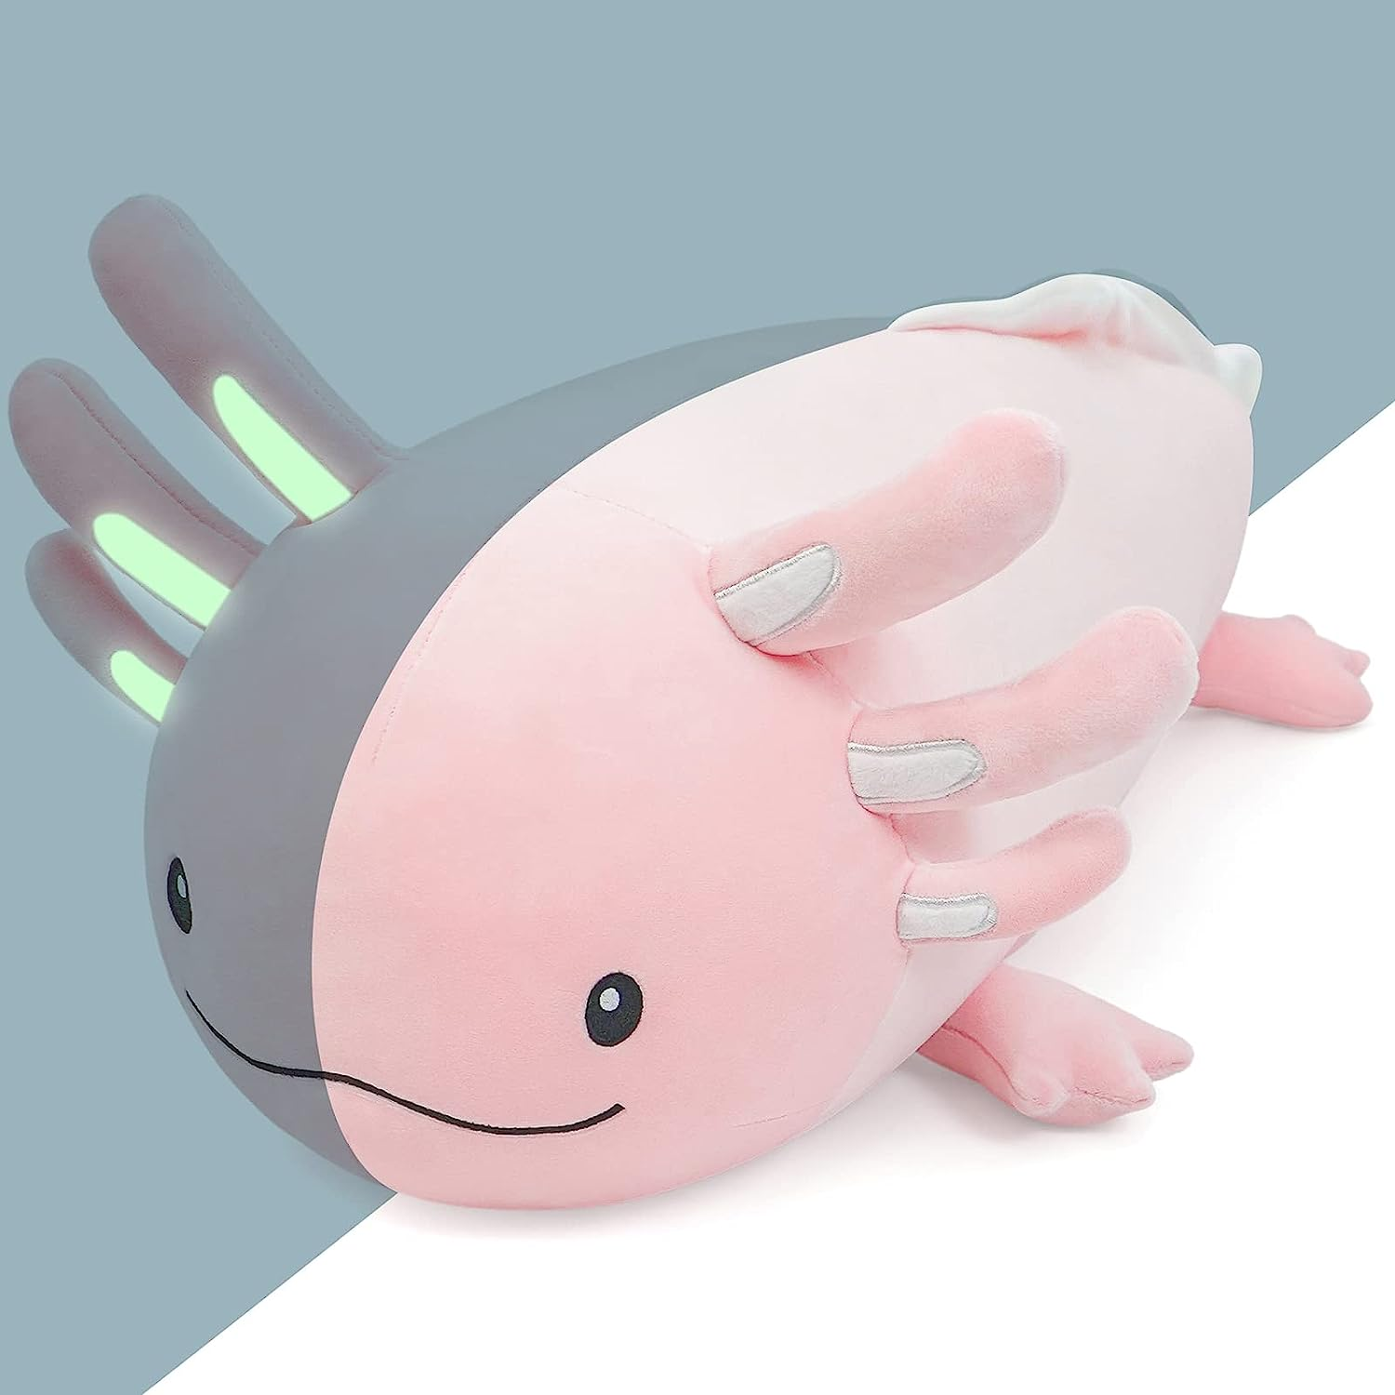

**ID:** S-05

**Color**: **25.5in-pink**

* Unique original design from Niuniu Daddy：Our designer designed this cute plush toy based on axolotl. Its night-shining gill makes this axolotl stuffed animals more fun for its owner. This kawaii plushie is a great gift for anyone in your life who loves axolotl.
* The breathe-gill of this Christmas axolotl plushie glow in the dark. This trait can help children who try to sleep alone overcome their fears but the light is not bright enough to disturb their sleep. The luminous material we used in the axolotl doll has passed safety tests and is skin-friendly.
* About 23.6inches. It's a suitable size for kids,toddler even teens and adult. To avoid the kids open the axolotl toy by accident and pull out the filler to everywhere, we removed the chain from the pink stuffed animal.
* Material:The appearance of this axolotl stuffed animal is made from polyester, which made your kids feel soft, comfortable and huggable. Filled with PP contton, this cosy axolotl doll is bouncy, and pleasing.
* The cute Christmas axolotl stuff does not have beads. It's stuffed cotton. It's very soft. No concern over loose beads or choking hazards.